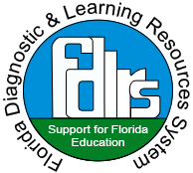

The Florida Department of Education’s FDLRS Child-find program¹ provides a free comprehensive screening assessment for children ages 3-5 years, in the areas of development, speech, language, vision, and hearing.
If there are any concerns noted in the screening, parent(s) can choose to have their child referred to their local school district for further testing. Further testing helps determine if the child is eligible to receive free services such as speech and language therapy sessions. See the Roadmap Through Child-Find.²

Call today! Find your local FDLRS Center³ contact here.
Phone: 386-312-2265

Starting individualized support services as early as possible can help your child learn and develop to their fullest potential!
¹https://www.fdlrs.org/child-find
² https://www.fdlrs.org/child-find/the-road-through-child-find-flyer
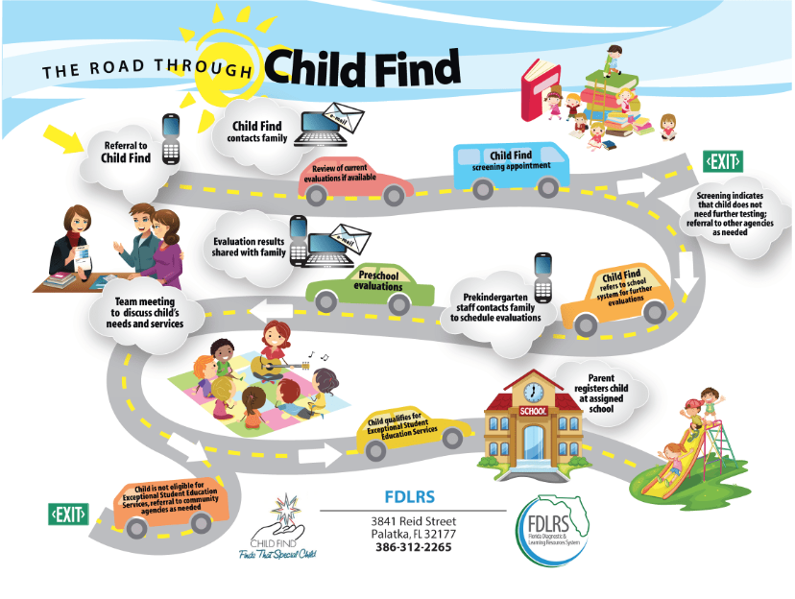
³https://www.fdlrs.org/fs/pages/339

