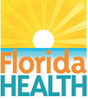

Florida’s Early Steps program partners with providers and families to deliver services that support a child’s well-being and development where they live, learn, and play. For more information see: Early Steps | Florida Department of Health¹

Early Steps offers individualized support services to eligible infants and toddlers (birth to 3 years) with developmental delays or a condition that may result in a delay. There is no income requirement to qualify for the program and families are not charged for services. To find out what to expect after referring a child to Early Steps, see the Early Step Enrollment Roadmap²
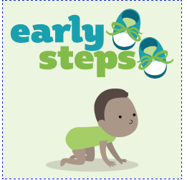
Call Early Steps Today to get started!
Toll-free: 1-800-374-4334

Starting individualized services early puts children on the right path to learn and develop to their fullest potential.

¹https://floridaearlysteps.com/
²https://www.fdlrs.org/child-find/the-road-through-child-find-flyer

