July 2022

Dear Kindergarten Parents and Caregivers,

Congratulations, and welcome to kindergarten in Kansas! This is an exciting time for you, your child and your school.
The Kansas State Board of Education sets our Kansans Can vision for education: Kansas leads the world in the success of each student. Early childhood experiences lay the foundation for a child’s future academic success. Thank you for the key role you already have played in learning and growing with your child.
Kansas elementary schools are partnering with families to better understand kindergartners’ development by using the Ages & Stages Questionnaires®, Third Edition (ASQ-3), and the Ages & Stages Questionnaires®: Social-Emotional, Second Edition (ASQ:SE-2). These questionnaires provide a snapshot of a child’s development. Since you know your child best, you complete both versions of the questionnaires. Your child’s kindergarten teacher will share more information about the ASQ-3 and the ASQ:SE-2. After learning more, you may decide if you choose to complete the questionnaires.
All children are ready to enter kindergarten when they meet the age requirement – 5 years old on or before Aug. 31 of their kindergarten year. This data identifies students’ strengths and areas where they may need support. Understanding each incoming student's development helps teachers prepare for the year. At the state level, this data helps inform opportunities to improve kindergarten readiness.
I wish you and your child a wonderful year in kindergarten.
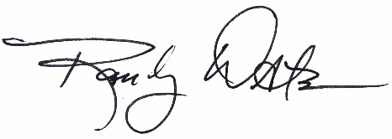
Sincerely,

Dr. Randy Watson
Kansas Commissioner of Education

